BENAZIR BHUTTO SHAHEED UNIVERSITY OF LYARI
CS/IT DEPARTMENT



RETAIL STORE DATA BASE SYSTEM
LAB MANUAL

Program: BS Artificial Intellegence (1st Batch) – Sec: B
Course: Database
Instructor: Sir Anwar Ali Sathio
Semester: 4th Semester
Members:
Muhammad Kabeer (B2433083)
Muhammad Sohaib (B2433086)

RETAIL STORE DATA BASE SYSTEM

Table of Contents

Chapter 1: Installation software & Introduction
  - Database Systems
  - Retail Store Database
  - Database Overview
  - Definition of Database
  - Components of Database

ERD
  - Queries

Chapter 2:Project Overview
  - Purpose of the Project
  - Goals
  - Tools Used
  - Real-World Example (Imtiaz Super Market)
  - Use of Retail Database in Real Stores
  - Automation of Store Operations

Chapter 3:Entities and Attributes
  - List of Entities
  - Description of Attributes
  - Relationships Between Entities

Chapter 4:Normalization
  - 1NF Overview
  - 2NF Overview
  - 3NF Overview

Chapter 5: SQL Joins
  - Purpose of Joins
  - Types of Joins
  - Example Join Query

Chapter 6: Database Triggers & Automation
6.1. Trigger Purpose

6.2 Stock Update Automation

Chapter 7: Indexing in Database
  - Importance of Indexes

  - Indexes Used in Project

Chapter 8: Security Features

  - User Roles
  - Privileges & Restrictions
  - Transaction Safety
  - Why Security is Important
  - Data Protection
  - Access Control
  - Error Prevention

Chapter 9: Conclusion

  - Final Summary
  - Benefits of the System

Step-by-Step MySQL Installation Guide:

- Download MySQL Installer:
Go to https://dev.mysql.com/downloads/installer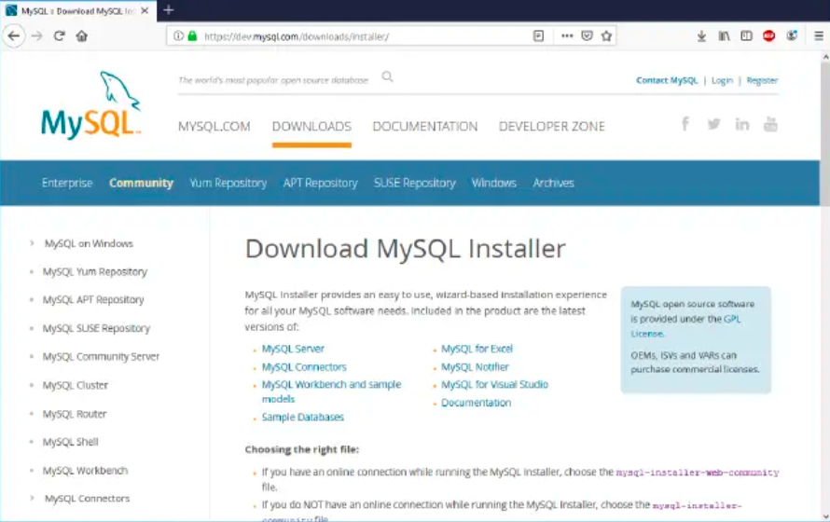

- Choose Setup Type:
Select Developer Default to install Workbench and MySQL Server.
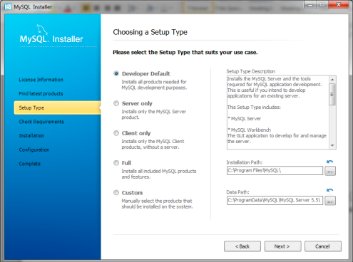

- Select Products and Features:
Confirm MySQL Server, Workbench, and Connector/J.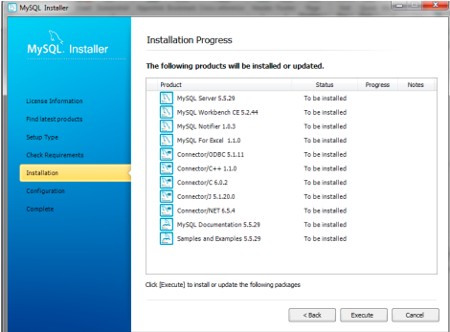

- Installation Process:
Click “Execute” to install all selected components.
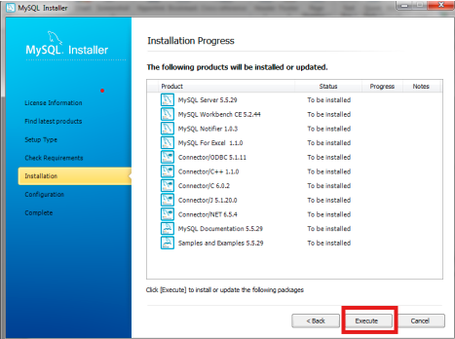

- MySQL Server Configuration:
  - Choose Standalone mode
  - Default port: 3306
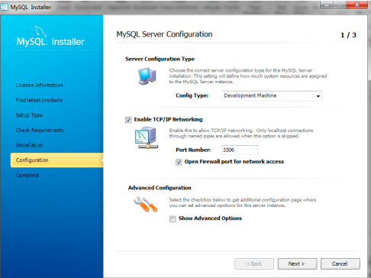

- Set Root Password:
Choose a secure password and remember it.
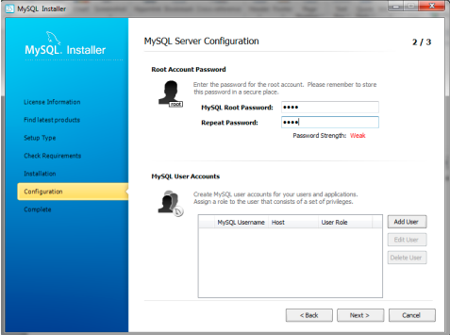

- Complete Installation:
Launch MySQL Workbench after installation.
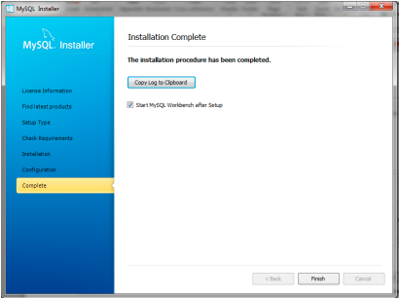

- Verify Installation:
Open Workbench → Create a new connection → Test Connection → Run a sample query.
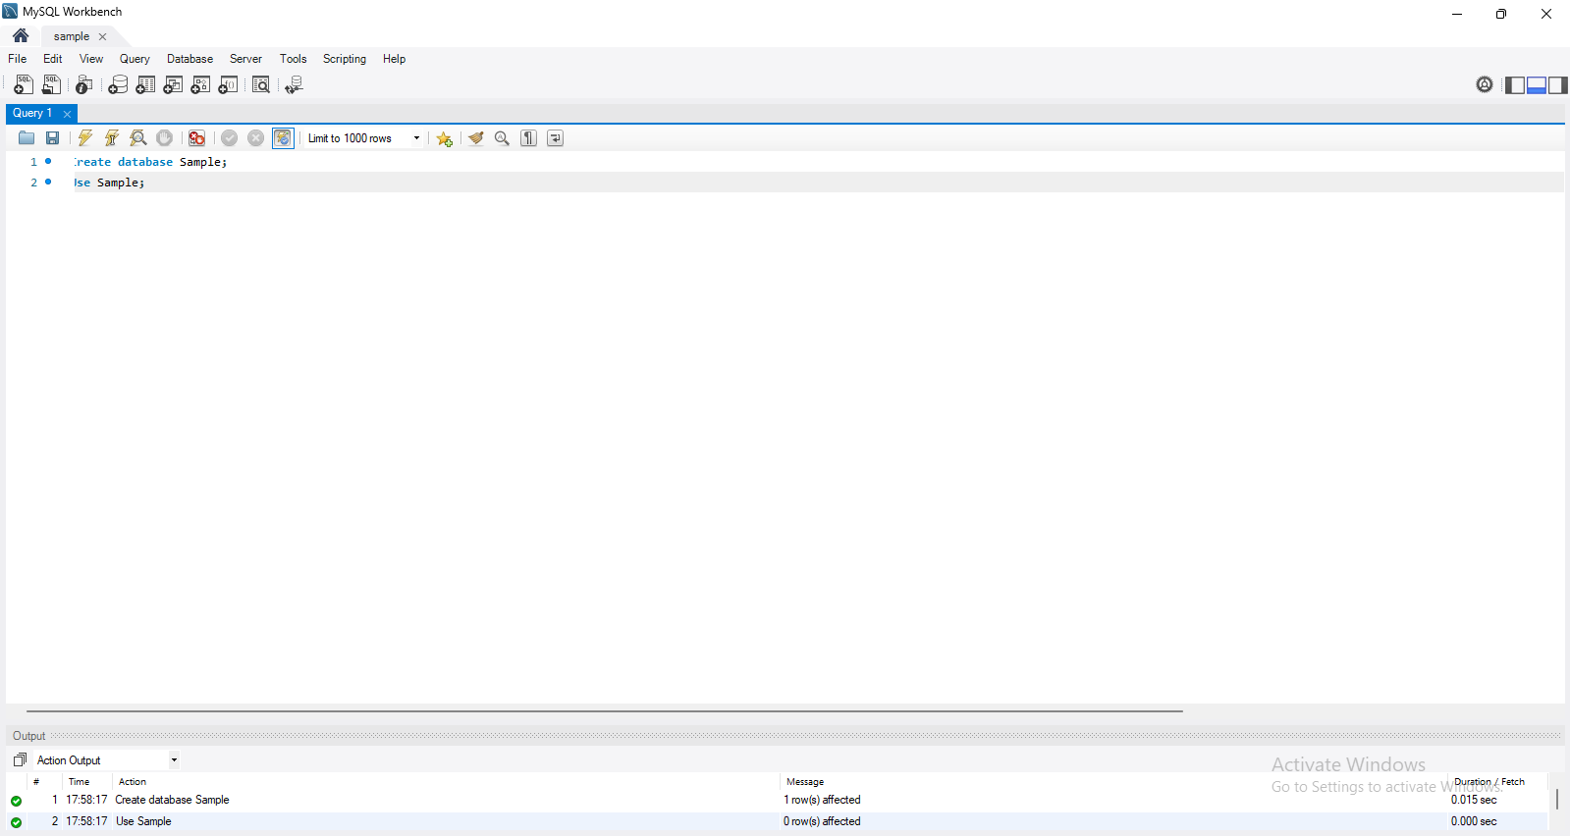

Chapter 1: Introduction

Database Systems
A database system is a structured way to store, manage, and retrieve data using a
Database Management System (DBMS).
Components:
  - Hardware: Computers and storage devices.

  - Software: DBMS like MySQL, Oracle.

  - Data: Stored information (e.g., student records).

  - Users: Admins, developers, and end users.

2 Retail Store Database
A Retail Store Database ek structured collection of information hai jo retail store ke tamam operations
ko manage karta hai, jaise ke sales, inventory, customers, aur suppliers.

Purpose:

  - Products ki stock tracking.

  - Sales transactions ko manage karna.

  - Customers aur suppliers ke records maintain karna.

  - Business ke liye reports generate karna.

Database Overview
  - Structured collection of data in tables for easy access and management
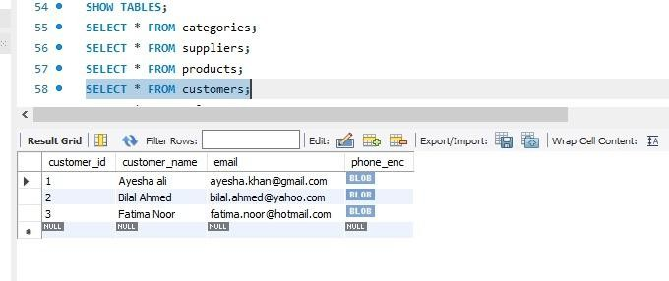
.

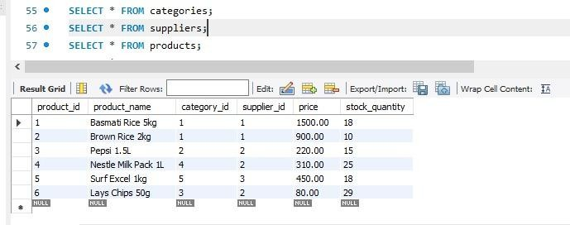

Definition of Database

A Database is a structured collection of related data that is stored and managed electronically.
It allows users to store, retrieve, update, and manage information efficiently.

Components of Database
  - Tables: Products, sales, suppliers, customers, inventory

  - Fields (Columns): product_name, price, quantity, etc.

  - Primary Key (PK): Unique ID per record (product_id)

  - Foreign Key (FK): Connects related tables (category_id linking products and categories)

  - DBMS: Software like MySQL managing data storage and access

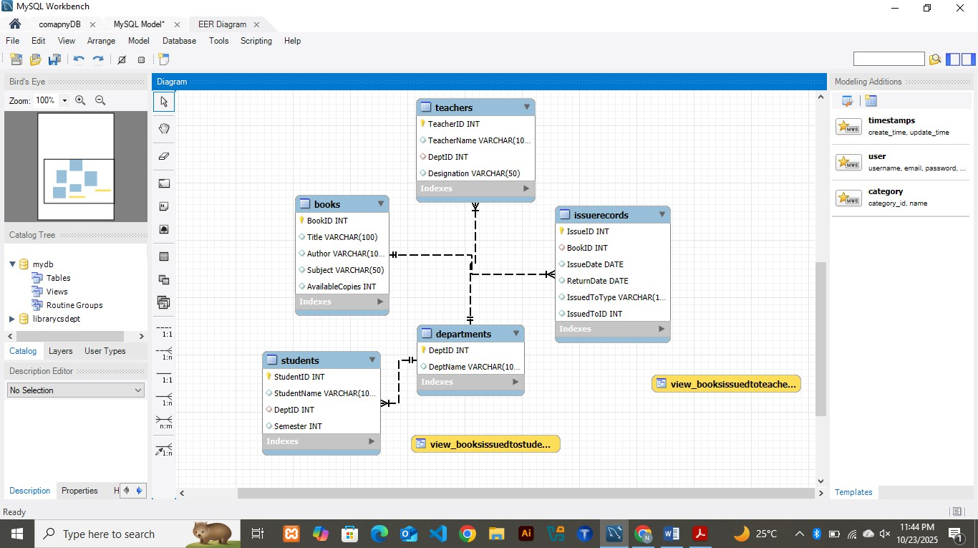
- ERD

Queries

CREATE DATABASE retail_store CHARACTER SET utf8mb4 COLLATE utf8mb4_unicode_ci;
USE retail_store;

CREATE TABLE categories (
category_id INT AUTO_INCREMENT PRIMARY KEY, category_name VARCHAR(100) NOT NULL
);

CREATE TABLE suppliers (
supplier_id INT AUTO_INCREMENT PRIMARY KEY, supplier_name VARCHAR(100) NOT NULL, contact_number VARCHAR(20),
email VARCHAR(100),
address TEXT
);
CREATE TABLE products
product_id INT AUTO_INCREMENT PRIMARY KEY,
product_name VARCHAR(100) NOT NULL, category_id INT,
supplier_id INT,
price DECIMAL(10,2) NOT NULL,
stock_quantity INT DEFAULT 0,
FOREIGN KEY (category_id) REFERENCES categories(category_id), FOREIGN KEY (supplier_id) REFERENCES suppliers(supplier_id)
);

CREATE TABLE customers (
customer_id INT AUTO_INCREMENT PRIMARY KEY, customer_name VARCHAR(100) NOT NULL,
phone VARCHAR(20), email VARCHAR(100)
);

CREATE TABLE sales (
sale_id INT AUTO_INCREMENT PRIMARY KEY,
customer_id INT,
sale_date DATETIME DEFAULT CURRENT_TIMESTAMP,
total_amount DECIMAL(10,2),
FOREIGN KEY (customer_id) REFERENCES customers(customer_id)
);

CREATE TABLE sale_items (
sale_item_id INT AUTO_INCREMENT PRIMARY KEY, sale_id INT,
product_id INT,
quantity INT NOT NULL,
price DECIMAL(10,2) NOT NULL,
FOREIGN KEY (sale_id) REFERENCES sales(sale_id), FOREIGN KEY (product_id) REFERENCES products(product_id)
);

CREATE TABLE inventory (
inventory_id INT AUTO_INCREMENT PRIMARY KEY, product_id INT NOT NULL,
quantity_in INT DEFAULT 0, -- kitna maal store me aya quantity_out INT DEFAULT 0, -- kitna maal becha gaya
last_updated DATETIME DEFAULT CURRENT_TIMESTAMP ON UPDATE CURRENT_TIMESTAMP,
FOREIGN KEY (product_id) REFERENCES products(product_id)
);CREATE INDEX idx_category ON products (category_id); CREATE INDEX idx_supplier ON products (supplier_id);
EXPLAIN SELECT * FROM products WHERE supplier_id = 2;USE retail_store
INSERT INTO categories (category_name) VALUES
('Grains & Rice'),
('Beverages'),
('Snacks'),
('Dairy Products'), ('Household Essentials');

INSERT INTO suppliers (supplier_name, contact_number, email, address) VALUES
('Al-Faisal Distributors', '03001234567', 'info@alfaisal.pk', 'Karachi, Pakistan'), ('Metro Suppliers', '03115678900', 'sales@metro.pk', 'Lahore, Pakistan'),
('SuperMart Wholesalers', '03227894561', 'orders@supermart.pk', 'Islamabad, Pakistan');

INSERT INTO products (product_name, category_id, supplier_id, price, stock_quantity) VALUES
('Basmati Rice 5kg', 1, 1, 1500.00, 20),
('Brown Rice 2kg', 1, 1, 900.00, 10),
('Pepsi 1.5L', 2, 2, 220.00, 15),
('Nestle Milk Pack 1L', 4, 2, 310.00, 25),
('Surf Excel 1kg', 5, 3, 450.00, 18),
('Lays Chips 50g', 3, 2, 80.00, 30);

INSERT INTO customers (customer_name, phone, email) VALUES
('Ayesha ali', '03001112223', 'ayesha.khan@gmail.com'), ('Bilal Ahmed', '03112223344', 'bilal.ahmed@yahoo.com'), ('Fatima Noor', '03334445566', 'fatima.noor@hotmail.com');

INSERT INTO sales (customer_id, total_amount) VALUES
(1, 1730.00),
(2, 900.00),
(3, 610.00);

INSERT INTO sale_items (sale_id, product_id, quantity, price) VALUES
(1, 1, 1, 1500.00),
(1, 3, 1, 220.00),
(2, 2, 1, 900.00),
(3, 4, 2, 310.00);

INSERT INTO inventory (product_id, quantity_in, quantity_out) VALUES
(1, 30, 10),

(2, 20, 5),
(3, 40, 25),
(4, 50, 10),
(5, 25, 7),
(6, 60, 30);

SHOW TABLES;
SELECT * FROM categories; SELECT * FROM suppliers; SELECT * FROM products; SELECT * FROM customers; SELECT * FROM sales; SELECT * FROM sale_items;
SELECT * FROM inventory;USE retail_store;

-- Show all products with their category and supplier names SELECT
p.product_name, c.category_name, s.supplier_name, p.price, p.stock_quantity
FROM products p
JOIN categories c ON p.category_id = c.category_id JOIN suppliers s ON p.supplier_id = s.supplier_id;

-- Show customers who made purchases

SELECT DISTINCT c.customer_name, c.phone FROM customers c
JOIN sales s ON c.customer_id = s.customer_id;

-- Average product price by category

SELECT c.category_name, AVG(p.price) AS avg_price FROM products p
JOIN categories c ON p.category_id = c.category_id GROUP BY c.category_name;

-- Total items sold per product SELECT
p.product_name, SUM(si.quantity) AS total_sold
FROM sale_items si
JOIN products p ON si.product_id = p.product_id GROUP BY p.product_name

ORDER BY total_sold DESC;

-- List all products with low stock SELECT product_name, stock_quantity FROM products
WHERE stock_quantity < 20;
-- Show each sale with total amount and customer name SELECT
s.sale_id, c.customer_name, s.sale_date, s.total_amount
FROM sales s
JOIN customers c ON s.customer_id = c.customer_id;

-- Show total quantity sold and total earning per customer SELECT
c.customer_name, SUM(si.quantity) AS total_items, SUM(si.price) AS total_spent
FROM customers c
JOIN sales s ON c.customer_id = s.customer_id JOIN sale_items si ON s.sale_id = si.sale_id GROUP BY c.customer_name;

-- Find which category has the highest total sales SELECT
c.category_name,
SUM(si.price * si.quantity) AS total_sales FROM sale_items si
JOIN products p ON si.product_id = p.product_id JOIN categories c ON p.category_id = c.category_id GROUP BY c.category_name
ORDER BY total_sales DESC LIMIT 1;START TRANSACTION;

UPDATE products SET stock_quantity = stock_quantity - 2 WHERE product_id = 6; COMMIT;USE retail_store;
-- Disable safe updates temporarily SET SQL_SAFE_UPDATES = 0;

-- Step 1: Add encrypted column
ALTER TABLE customers ADD COLUMN phone_enc VARBINARY(255);

-- Step 2: Encrypt existing phone numbers into the new column UPDATE customers
SET phone_enc = AES_ENCRYPT(phone, 'my_secret_key');

-- Step 3: Drop old plain text column
ALTER TABLE customers DROP COLUMN phone;

-- Step 4: Rename encrypted column back to 'phone'
ALTER TABLE customers CHANGE COLUMN phone_enc phone VARBINARY(255);

-- Step 5: Enable safe updates again SET SQL_SAFE_UPDATES = 1;

-- Optional: Check table to see only encrypted data SELECT customer_name, phone FROM customers;

FROM customers;DELIMITER //
CREATE PROCEDURE AddSale (IN p_customer_id INT) BEGIN
DECLARE total DECIMAL(10,2);
SELECT SUM(quantity * price) INTO total
FROM sale_items WHERE sale_id = LAST_INSERT_ID();
UPDATE sales SET total_amount = total WHERE sale_id = LAST_INSERT_ID(); END;
// DELIMITER ;

DELIMITER //
CREATE TRIGGER update_stock_after_sale AFTER INSERT ON sale_items
FOR EACH ROW BEGIN
UPDATE products
SET stock_quantity = stock_quantity - NEW.quantity WHERE product_id = NEW.product_id;
END;
// DELIMITER ;

- Show all

Chapter 2: System Analysis

Purpose of the Project

To design a retail database that efficiently manages products, suppliers, customers, sales, and stock inventory.

Goals
- Real-time and accurate management of store operations

- Reduce human errors in billing, inventory, and reporting

Tools Used
- MySQL Workbench + SQL queries

Real-World Example (Imtiaz Super Market)
- Centralized retail database maintains product/supplier records, tracks stock, manages invoices, and generates reports

Use of Retail Database in Real Stores.
Manages inventory, monitors sales, tracks suppliers, maintains customer records.

Automation of Store Operations

Automated billing, stock updates, and report generation reduce human error and save time.
●

Chapter 3: System Design

- List of Entities.
Categories, Suppliers, Products, Customers, Sales, Sale_Items, Inventory

- Description of Attributes

Categories: category_id, category_name Suppliers: supplier_id, supplier_name, contact_number, email, address
Products: product_id, product_name, category_id (FK), supplier_id (FK), price, stock_quantity Customers: customer_id, customer_name, phone, email
Sales: sale_id, customer_id (FK), sale_date, total_amount

Sale_Items: sale_item_id, sale_id (FK), product_id (FK), quantity, price Inventory: product_id (FK), stock_quantity

Relationships Between Entities

Category → Product: One-to-Many Supplier → Product: One-to-Many Customer → Sales: One-to-Many Sales → Sale_Items: One-to-Many Product → Sale_Items: One-to-Many
Product → Inventory: One-to-One/One-to-Many

Chapter 4:Normalization

1NF Overview
Data stored in atomic form, no repeating groups

2NF Overview
Partial dependencies removed; customers and sales separate

3NF Overview
Transitive dependencies removed; foreign keys connect related tables

Chapter :5 SQL Joins

Purpose of Joins:

The purpose of SQL joins is to combine data from two or more
tables using related keys.

Joins help retrieve complete information that is stored across multiple tables.

Why joins are used:

To connect related tables

    - To show relationships (Primary Key – Foreign Key) To generate combined reports
To display customer + order + product details together
    - To improve data clarity and meaning

Joins make database queries more efficient and meaningful.

  - Types of Joins:

1. INNER JOIN:
Returns only the matching records from both tables.

2. LEFT JOIN:
Returns all records from the left table, even if there is no match in the right
table.

3. RIGHT JOIN:
Returns all records from the right table, even if there is no match in the
left table.

4. FULL OUTER JOIN:
Returns all matching and non-matching records from both tables.

Example Join Query
FROM products p
JOIN categories c ON p.category_id = c.category_id JOIN suppliers s ON p.supplier_id = s.supplier_id;

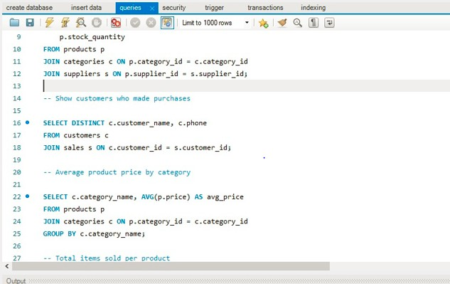

Chapter 6: Database Triggers & Automation

Trigger Purpose:
A trigger is an automatic action executed by the database when a specific event occurs.
Triggers help maintain consistency and automate tasks

Triggers are used for:

Automatic stock update

      - Maintaining logs

      - Enforcing business rules

      - Preventing human errors

      - Auto-execution of tasks on INSERT/UPDATE/DELETE

Stock Update Automation:
In the retail store system, whenever a product is sold, its stock is automatically reduced.
This is done using a trigger

Example Trigger:
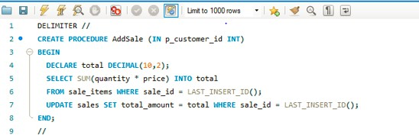

Chapter 7: Indexing in Database

Importance of Indexes:

Indexes make data searching and retrieval faster.
An index acts like a table of contents in a book.

Importance:

Faster searching

    - Faster filtering
    - Faster sorting

    - Efficient handling of large data

    - Reduces query execution time

Without indexes, the database performs full table scans which slows down performance.

Indexes Used in the Project:

Primary Key Index
Automatically created by the system for all primary key columns: CustomerID, ProductID, OrderID, OrderItemID.

Foreign Key Index
Created to speed up joins between related tables.

Chapter 8: Security Features

User Roles

Role-based access ensures each user has controlled permissions.

Roles Used:
Admin: Full control

Manager: Can add, update, view data Cashier: Can enter sales/orders only Viewer: Read-only access

Privileges & Restrictions

Privileges include

. SELECT

. INSERT

. UPDATE

. DELETE

. CREATE

.DROP

Restrictions:

.Cashier cannot delete records

.Viewer cannot update data

.Only admin can manage users

Transaction Safety:

Transaction safety ensures data integrity.

Features:
- Atomic updates

- Rollback on error

- Prevents partial data
- Maintains database consistency Transactions follow ACID properties.

Why Security is Important:

Security is important because:
    - It protects database from unauthorized access
    - Prevents data theft
    - Avoids corruption and hacking
    - Maintains privacy and integrity

Data Protection

Data protection in the system includes:
    - Password-protected login
    - Role-based access
    - Backup procedures
    - Triggers and constraints to prevent errors

Access Control
Access control defines:
    - Who can access which table
    - What operations they can perform
    - Which module a user belongs to This helps maintain safety and control.

Error Prevention
Errors are prevented using:
    - Constraints

    - Validation rules
Auto-triggers
    - Data type checks
    - Foreign key relationships

Prevents issues like:
    - Negative stock
    - Wrong product ID
    - Duplicate customer entries

Chapter 9: Conclusion

Final Summary:
This project successfully developed a retail store database system that automates daily store operations.
It helps manage:
    - Customer data

    - Product information

    - Stock levels

    - Orders and sales

    - Automated stock updates

    - Reports and record tracking

Overall, the system is fast, efficient, and user-friendly

Benefits of the System:

9.2 Benefits of the System

Key Benefits:
    - Automatic stock update
    - Organized customer and order management
    - Less manual errors
    - Easy and quick searching due to indexing
    - Role-based security
    - Better control over store operations
    - Fast data retrieval

